Fab Print Room Orientation

This document outlines the necessary steps for those who are to be trained on 3D printers in the TSD FAB PRINT ROOM. This training plan must completed prior to gaining authorization to operate and maintain our various TSD 3D printers. This orientation plan does not implicitly grant authorization to members who satisfactorily complete it. It only allows said team members to be designated as authorized operators of specific printers as seen fit by our leadership.

Day 1

**Background and Basics**

[MIT 3D Print Video](https://www.youtube.com/watch?v=ICjQ0UzE2Ao)

**Physical Orientation in TSD FAB 3D Print Room**

General talking points –

Basic flow of print jobs in and out of our room

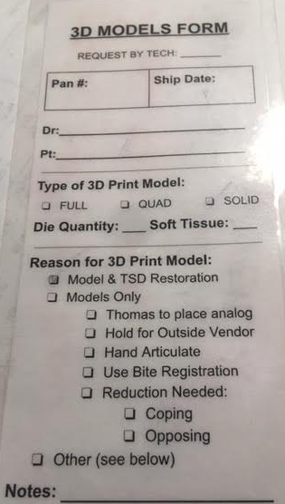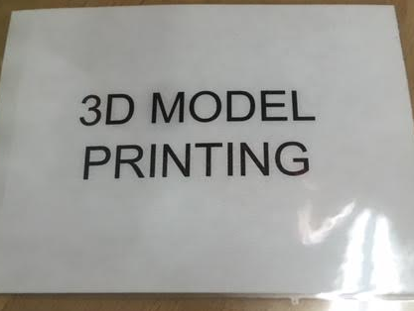

Kinds of prints –

Models

Implants

Wax Rims

Custom Trays

Emax / PFM crowns

Frames

Surgical guides / jigs

Night guards

Dentures

Introduction to each printer type and make in our room

FFF - Creality CR10

SLA - Formlabs Form3B

SLA (DLP) - envisionOne cdlm

SLA (DLP) – Desktop Health Einstein

Jetted Material - Stratasys Objet

SLA (CLIP) - Carbon M2

SLA – HeyGears A2D4K + HIVE

Overview of processes of each printer

Creality CR10 – Design, nest/convert, print

Formlabs Form3 – Nest, print, post process / cure

Carbon M2 – Nest, print, post process / cure

envisionOne cdlm – Nest, print, post process / cure

Desktop Health Einstein – Nest, print, post process / cure

HeyGears A2D4K + HIVE – Nest, print, post process

Basic terminology

Supports and associated dimensions / variables

Base / raft and associated dimensions / variables

Materials and associated characteristics

Quiz

Day 2

Detailed Training on simple post processing / curing

Clean as you go process fundamentals

Formlabs Form3B

Carbon M2

HeyGears A2D4K + HIVE

envisionOne cdlm

Desktop Health Einstein

Quiz

Day 3

Basic daily maintenance / upkeep on printers / machines

Utilizing maintenance and equipment board basics

Formlabs Form3

Carbon M2

HeyGears A2D4K + HIVE

envisionOne cdlm

Desktop Health Einstein

Clean as you go process review

Weekly maintenance / upkeep on printers / machines

Formlabs Form3

Carbon M2

HeyGears A2D4K + HIVE

envisionOne cdlm

Desktop Health Einstein

Quiz

Day 4

Basic setup, nesting, and misc.

Formlabs Form3

Carbon M2

HeyGears A2D4K + HIVE

envisionOne cdlm

Desktop Health Einstein

Creality CR10

Clean as you go process review

Common defects and mitigation

Proper documentation of defects and troubleshooting efforts

Quiz

Day 5

Live run and final test.

Envisiontec cdlm / Desktop Health Einstein and/ or HeyGears A2D4K + HIVE certification tests upon management request.